

**Ministry of Education and Training**

**FPT University - Can Tho Campus**

**Major: Software Engineering**

**DESKTOP JAVA APPLICATIONS**

**ASSIGNMENT REPORT**

**TOPIC : HOTEL MANAGEMENT**

**GROUP 8 - SE1402 - SPRING2020**

**MEMBER:**

**NGUYỄN HOÀNG GIA KHÁNH - CE140504**

**LÊ MINH NGHĨA - CE140071**

**PHAN THANH LIÊM - CE140563**

**TEACHER:**

**LƯƠNG HOÀNG HƯỚNG**

**Can Tho City, March 26, 2020**

**GREETING**

According to the assignment of Master Lương Hoàng Hướng, we decided to make an application to manage hotel information. To complete this project, we are so thankful to Mr. Hướng to teach us much knowledge about Object-Oriented Programming using Java and Desktop Java Applications. We couldn’t finish this without you.

This product maybe our best effort at this moment. However, there are a lot of things we need to discuss more, learn more and fix more after this subject to improve our skills in the future. We love to get many suggestions about this project from teachers and classmates to improve our next projects.

Many thanks to everybody!

Can Tho City, March 26, 2020

Partipation

Nguyễn Hoàng Gia Khánh

Lê Minh Nghĩa

Phan Thanh Liêm

**BRIEF**

Nowadays, traveling are one of the major services in many countries around the world. And the need of using hotel are increasing. However, lots of hotels can’t manage their information well without using database in the computers.

Therefore, we decided to make an application to manage the hotel system well to improve management of hotel administrator by using software technology. This project is using Java language with open source code.

**GROUP INFORMATION**

- Nguyễn Hoàng Gia Khánh - CE140504 (Leader)

- Lê Minh Nghĩa - CE140071

- Phan Thanh Liêm - CE140560

Contact us at : FPT University - Can Tho Campus, 600, Nguyen Van Cu Street (extended), An Binh Ward, Ninh Kieu District, Can Tho city

**HARDWARE AND SOFTWARE REQUIREMENTS**

1. **Hardware requirements** (Recommended for Microsoft Window operating system)

- Processor : 780 MHz Intel Pentium III workstation or equivalent

- Memory : 512 MB

- Disk Space : 125 MB of free disk space

1. **Software requirements** (Recommended for Microsoft Window operating system)

- The PHP and C/C++ **NetBeans** bundles only require the Java Runtime Environment (JRE) 7 or JRE 8 to be installed and run.

- Java features in the IDE require JDK 7 or JDK 8. JavaFX 2.2 (or newer) features require JDK 7 Update 6 (or newer).

- JavaFX 8 features require JDK 8.

**PROGRAM DETAILS**

1. **ACCESSIBLE USER FUNCTIONS**

- Administrator: Login, Manage (room, service, customer, employee, statistical, account)

- Staff: Login, Manage (Customer, check in, check out)

1. **JAVA INTRODUCTION (according to W3SCHOOLS)**
2. What is Java?

Java is a popular programming language, created in 1995.

It is owned by Oracle, and more than ****3 billion**** devices run Java.

It is used for:

* Mobile applications (specially Android apps)
* Desktop applications
* Web applications
* Web servers and application servers
* Games
* Database connection
* And much, much more!

1. Why use Java?

* Java works on different platforms (Windows, Mac, Linux, Raspberry Pi, etc.)
* It is one of the most popular programming language in the world
* It is easy to learn and simple to use
* It is open-source and free
* It is secure, fast and powerful
* It has a huge community support (tens of millions of developers)
* Java is an object oriented language which gives a clear structure to programs and allows code to be reused, lowering development costs
* As Java is close to [C++](https://www.w3schools.com/cpp/default.asp) and [C#](https://www.w3schools.com/cs/default.asp), it makes it easy for programmers to switch to Java or vice versa

1. Example of Java code

public class **MyClass** {

public static void **main**(String[] args) {

System.out.println("Hello World");

}

}

1. **NETBEAN INTRODUCTION (**<https://netbeans.org/about/>)

Most developers recognize the NetBeans IDE as the original free Java IDE. It is that, and much more! The NetBeans IDE provides support for several languages (PHP, JavaFX, C/C++, JavaScript, etc.) and frameworks.

NetBeans is an open-source project dedicated to providing rock solid software development products (the [NetBeans IDE](https://netbeans.org/features/ide/index.html) and the [NetBeans Platform](https://netbeans.org/features/platform/index.html)) that address the needs of developers, users and the businesses who rely on NetBeans as a basis for their products; particularly, to enable them to develop these products quickly, efficiently and easily by leveraging the strengths of the Java platform and other relevant industry standards

1. **SQL SERVER**
2. What is SQL Server

SQL Server is a relational database management system (RDBMS) developed by Microsoft. It is primarily designed and developed to compete with MySQL and Oracle database.

SQL Server supports ANSI SQL, which is the standard SQL (Structured Query Language) language. However, SQL Server comes with its own implementation of the SQL language, T-SQL (Transact-SQL).

****T-SQL**** is a Microsoft propriety Language known as ****Transact-SQL.**** It provides further capabilities of declaring variable, exception handling, stored procedure, etc.

SQL Server Management Studio (SSMS) is the main interface tool for SQL Server, and it supports both 32-bit and 64-bit environments.

1. Entity Relationship model

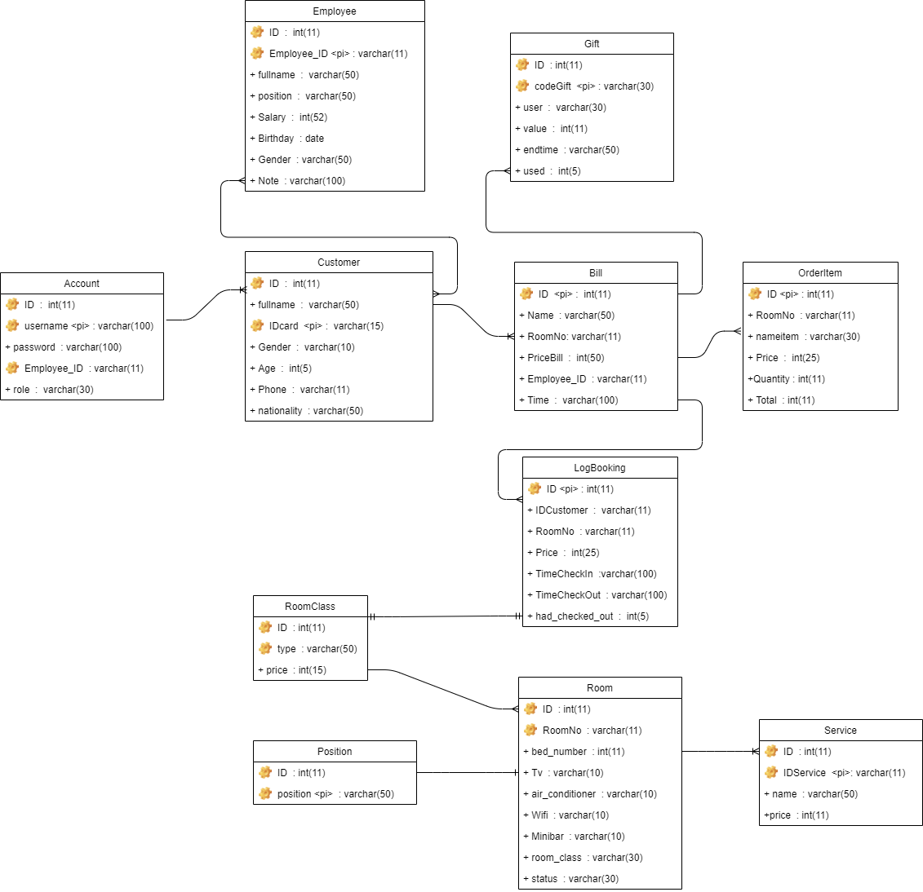

1. Entities

- Entity Account

Explain: Allows the user to log in to the application with username and password from admin.

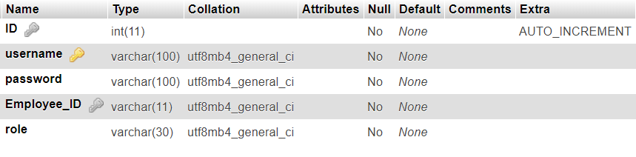

- Entity Bill

Explain: Find price of all service and room had use throw time.

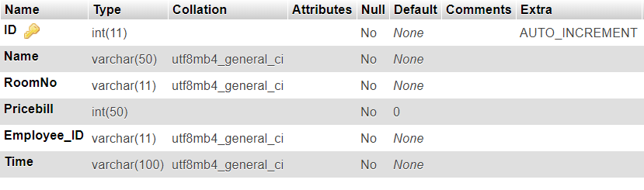

- Entity Customer

Explain: Get information of customer.

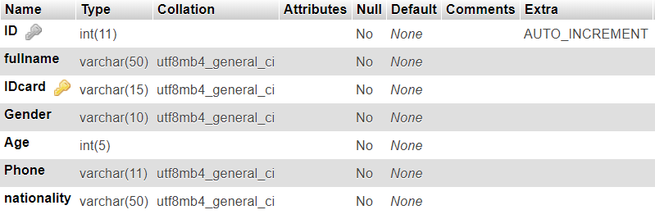

- Entity Employee

Explain: Get information of Employee.

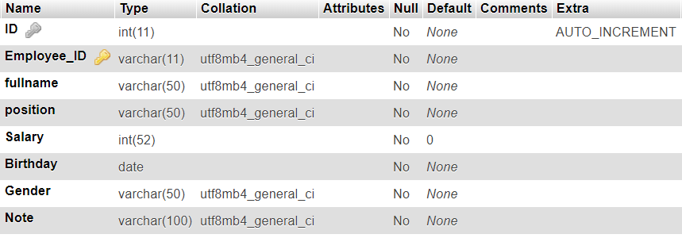

- Entity Gift

Explain: To create gift for customer when get a bill.

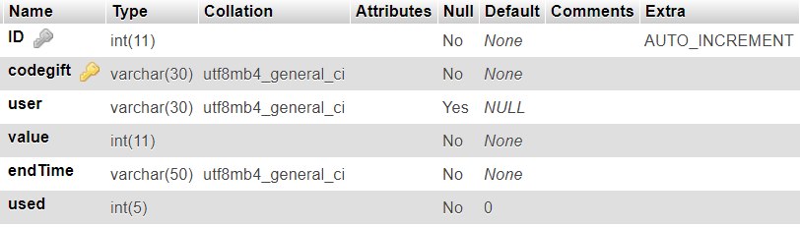

- Entity Log_Booking

Explain: Get time in and out of customer to find price.

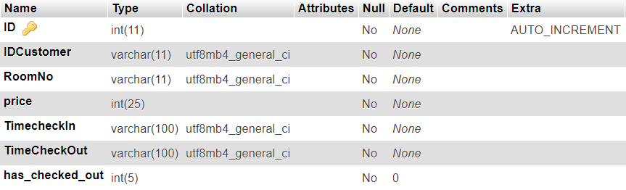

- Entity OrderItem

Explain: to get number, name and price of the item customer had used.

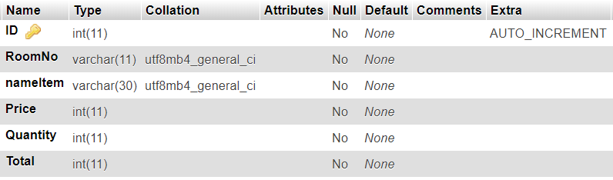

- Entity Room

Explain: To check status of room and get information of items in room.

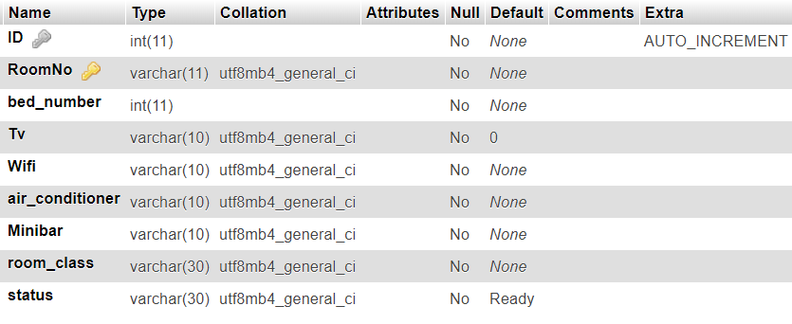

- Entity Room_Class

Explain: to get type and price of the room.

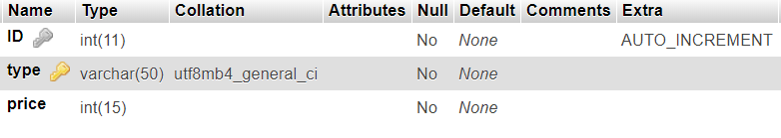

- Entity Service

Explain: to get information of service.

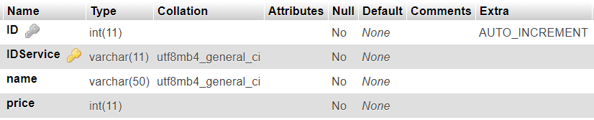

- Entity Position

Explain: to get position of room.

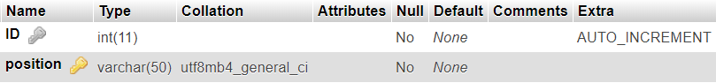

**USER INTERFACE**

1. **LOGIN INTERFACE**

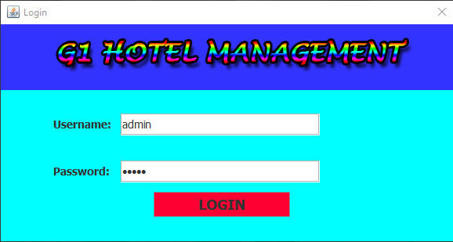

Figure 1: Login interface for both administrator and staff

1. **ADMIN INTERFACE**
2. Home Interface

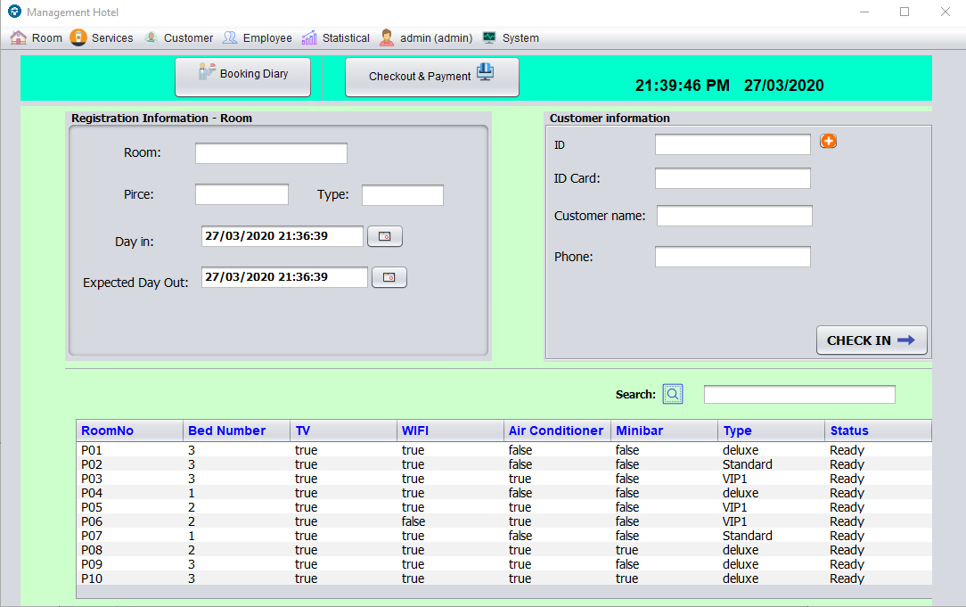

Add Customer

Figure 2 : Home interface for administrator

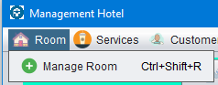 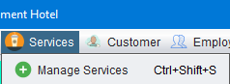

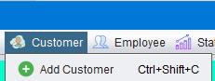 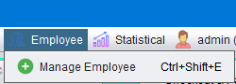

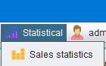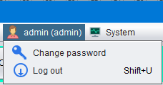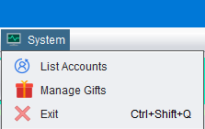

Figure 3 : Functions on Menu Bars

1. Room Management

*Room => Manage Room => Room Information => Insert new Room information => Add => OK

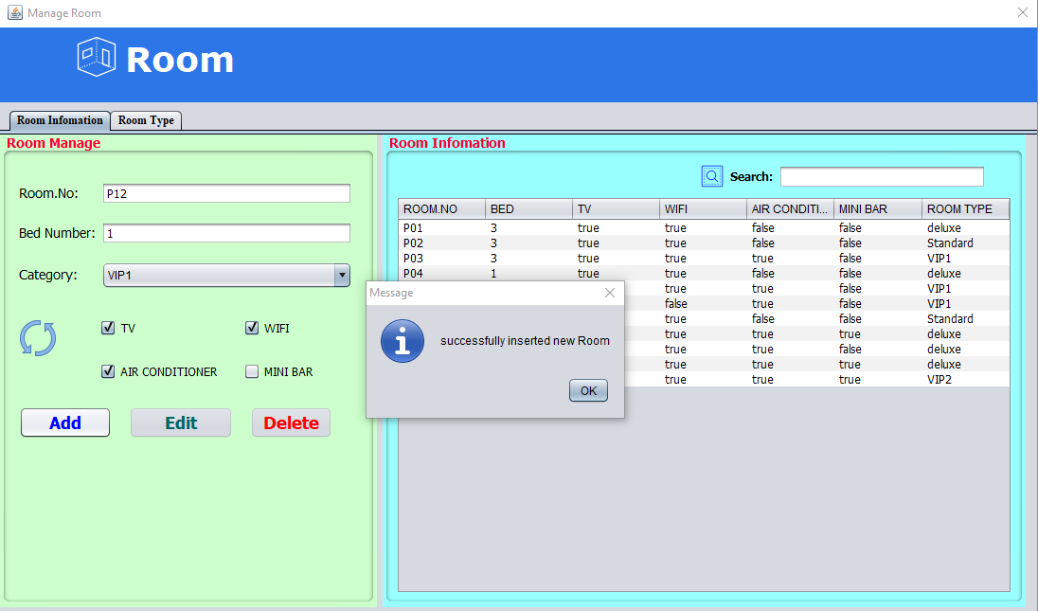

Figure 4 : Manage Room information

*Room => Manage Room => Room Type => Insert new Room type => Add => OK

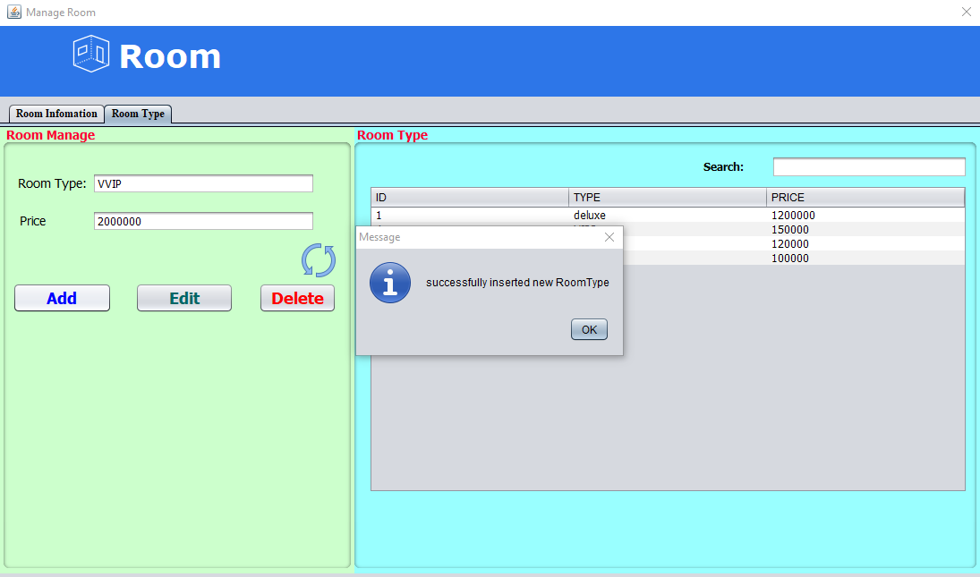

Figure 5 : Manage room type

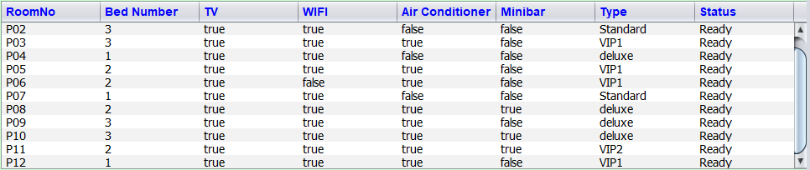

Figure 6 : Room list after adding

*Customer => Add Customer => Insert new customer information => Add => OK

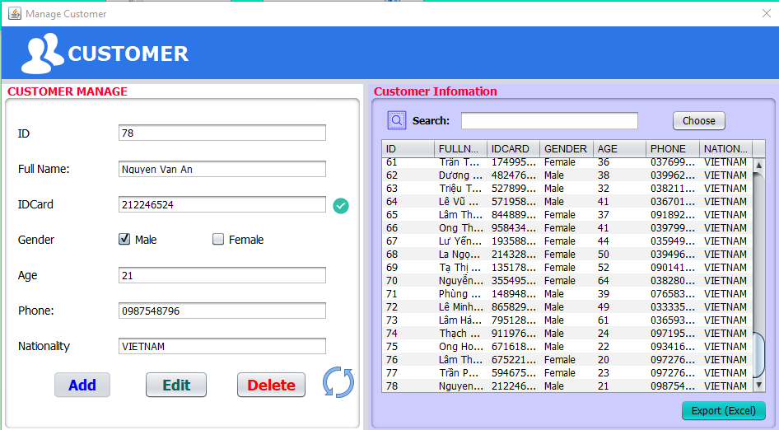

Figure 7 : Adding customer using Add Customer button

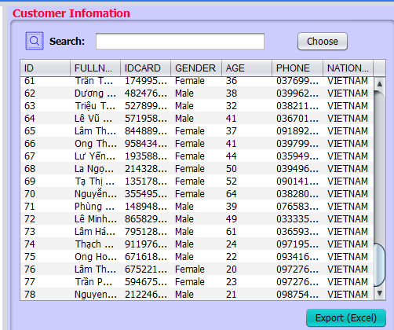

Figure 8 : Customer list after adding

*(+) => Choose customer from table => Choose

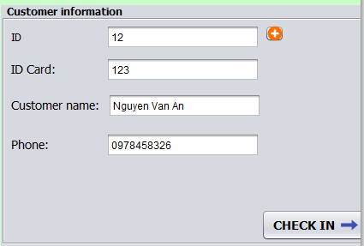

Figure 9 : Showing information after choosing customer in the customer list

*Choose Room from the room table => Set day in and expected day out => CHECK IN => OK

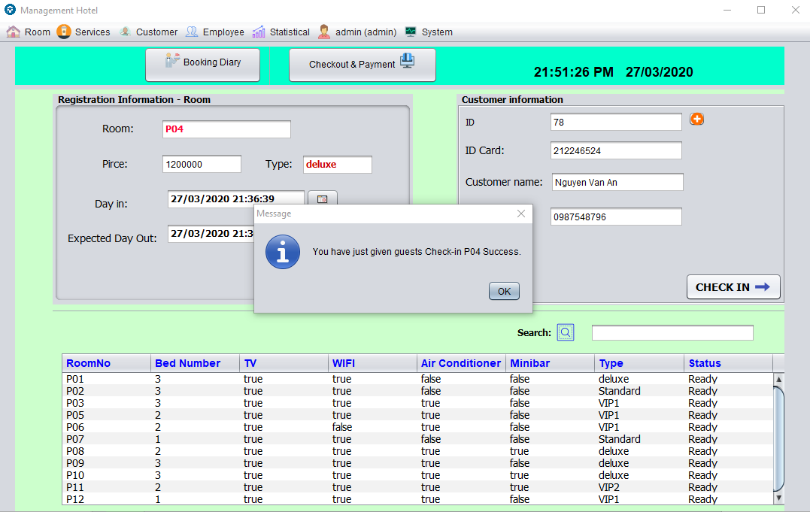

Figure 10 : Succesfully registrating new room for customer Nguyen Van An

*Checkout & Payment => Select room number => Generate Payment => Insert Code gift and Chect Gift (if possible) => Checkout

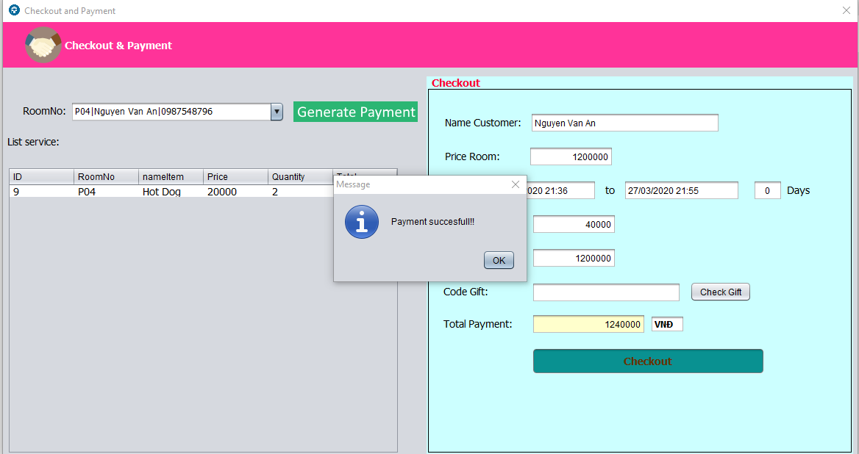

Figure 11 : Checking out using Check out & Payment button

1. Service Management

*Service => Manage Service =) Insert new Service information => Add => OK

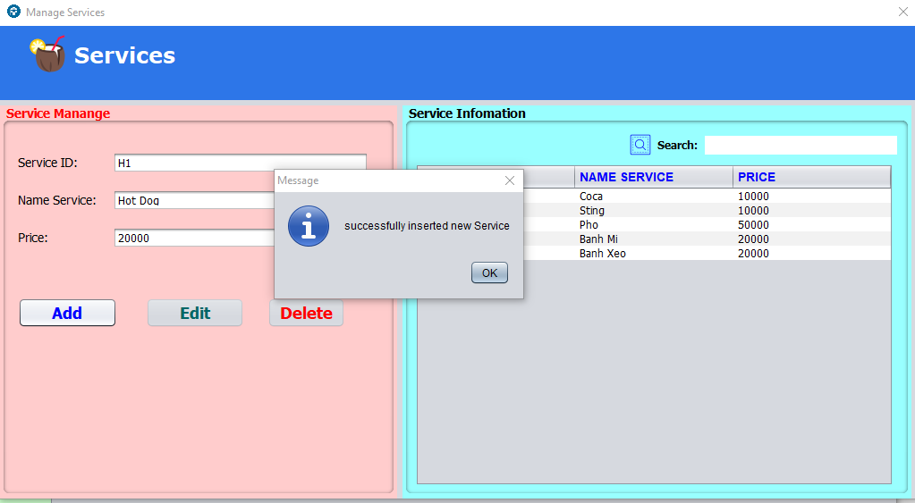

Figure 12 : Adding service Hot Dog

*Booking Diary => Choose room number => Choose item from the table => Insert quantity => Save => OK

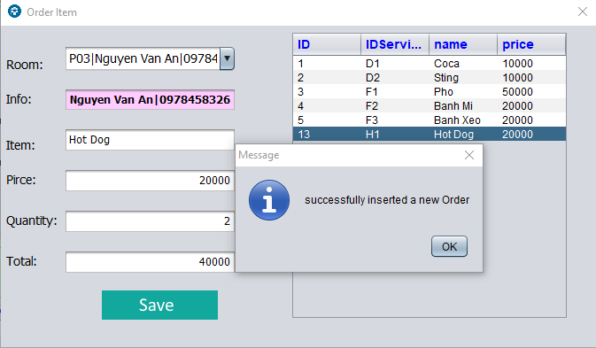

Figure 13 : Ordering service for customer using Booking Diary button

1. Employee Management

*Employee => Manage Employee => Insert new employee information => Add => OK

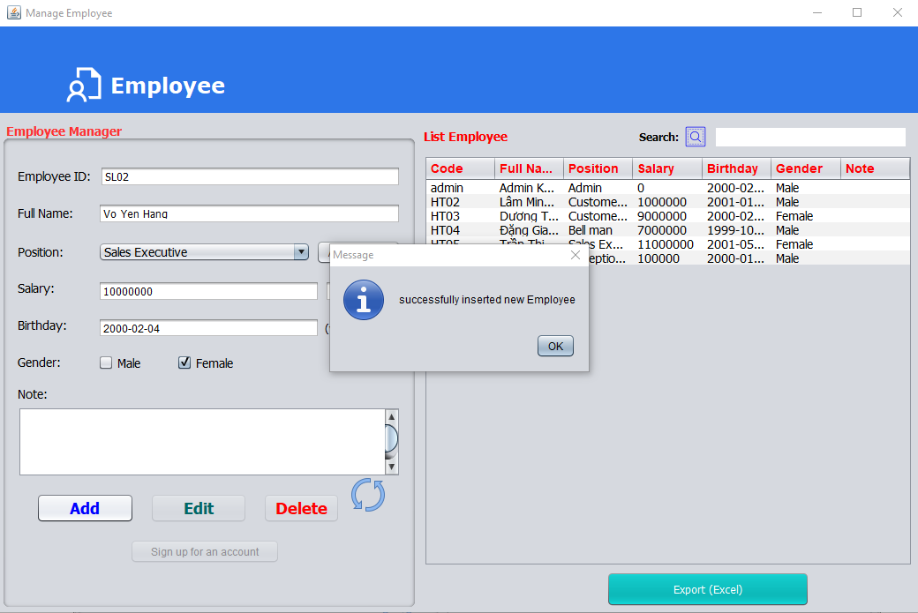

Figure 14 : Adding new employee information

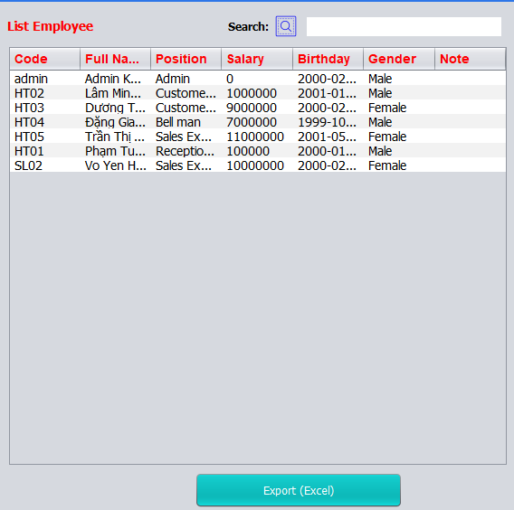

Figure 15 : Employee list after adding

*Employee => Manage Employee => Choose employee from the table => Sign up for an account => Insert account information => Sign up => OK

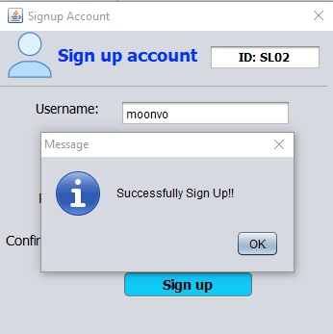

Figure 16 : Creating new login account for the newest employee

*Employee => Manage Employee => Export (Excel) => Choose file location => Save => OK

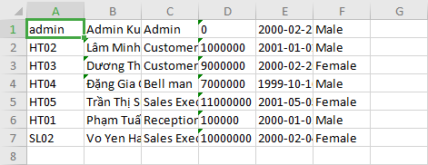

Figure 17 : Employee file after exporting

1. Sale Statistics

*Statistical => Sale Statistics => Choose date range => View

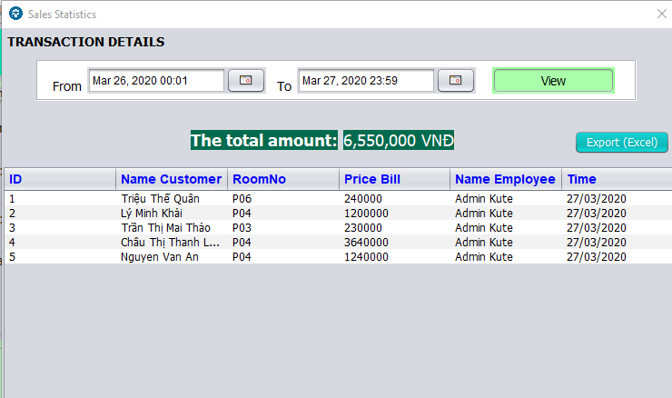

Figure 18: Checking exchange from date to date

*Statistical => Sale Statistics => Choose date range => View => Export (Excel)

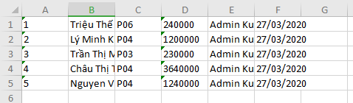

Figure 19 : Sale statistics file after exporting

1. Administrator Information Management

* admin (admin) => Change Password => Insert information => OK

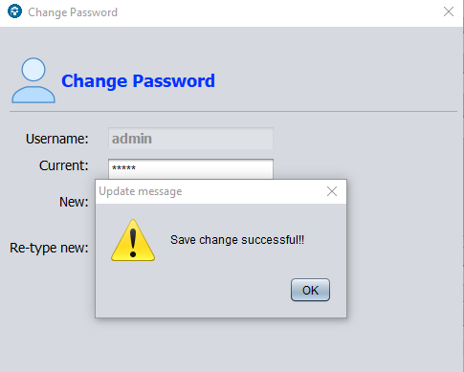

Figure 20 : Changing password for admin account

*System => List Accounts

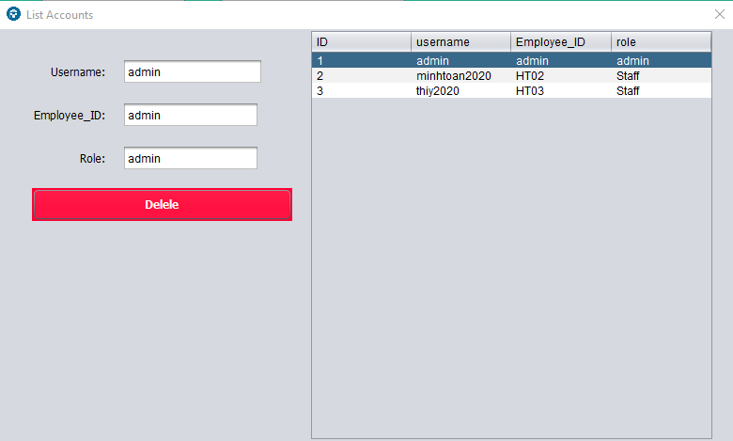

Figure 21 : List Account for login

*System => Manage Gifts => Insert new gifts coupon information => Create Gift => OK

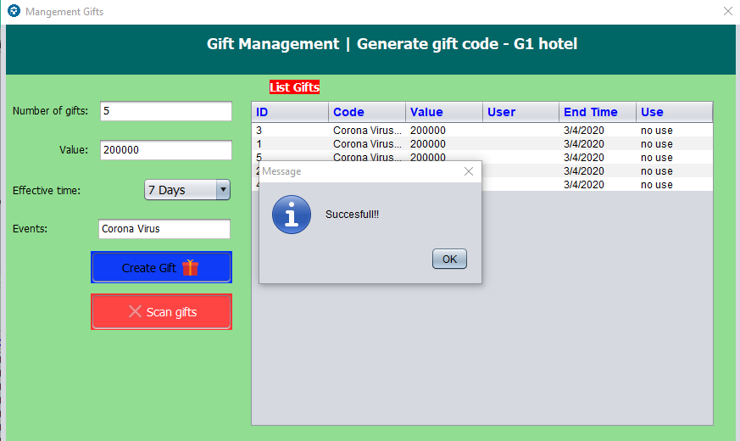

Figure 22 : Creating Coupon

1. **STAFF INTERFACE**

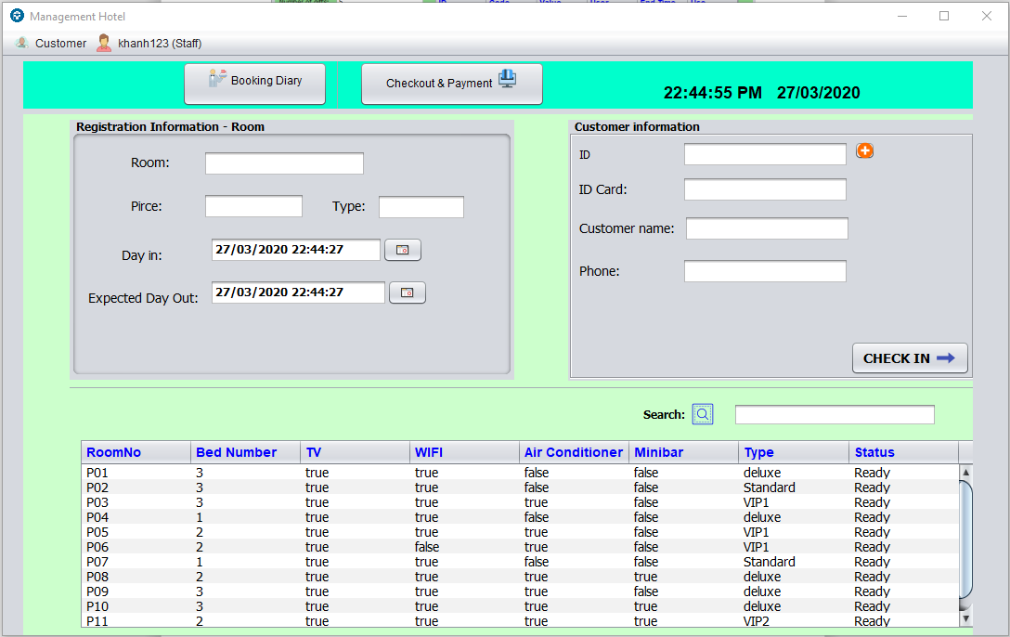

Figure 23 : Staff Interface, with less functions than Admin Interface